ETL PROJECT REPORT
Bikeshare Program
December 19, 2020
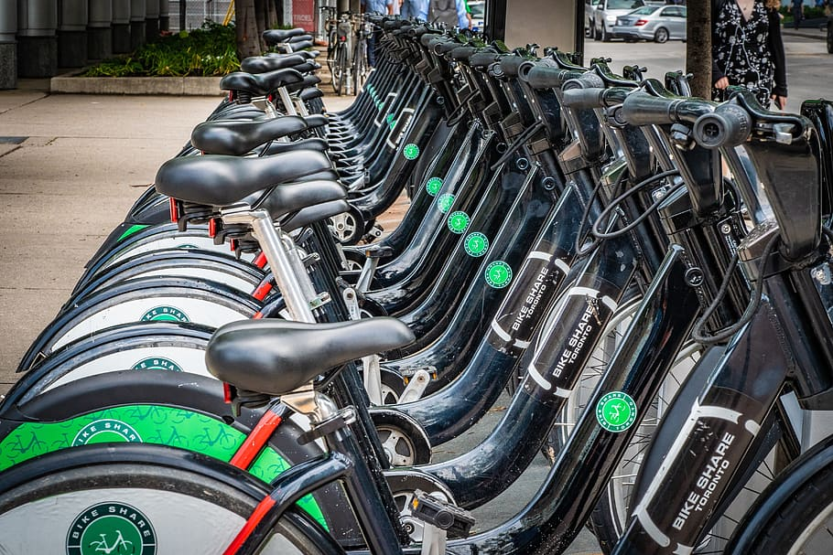
Catherine Tratnik
Manisha Lal
Myfanwy Brown-Robinson
Rubalpreet Bhullar
Sharanvika Jegatheeswaran

INTRODUCTION
Bike-sharing is a form of transportations that has seen a significant increase in usage globally. The current shift to usage of more sustainable transportation is a trend that embraces the onset of reducing carbon emissions and allocated capital investments from urban transport. The onset helps our economy benefits our economy by encouraging methods in preventing global warming, which in turn allows us to allocate the extra capital investment into other projects that can further provide a stable infrastructure. Not only does this program provide benefits to our economy but it also encourages our public to maintain a healthy lifestyle.

As the Ministry of Transportation, we want to understand the feasibility of implementing a bike-sharing program across Canada. In Canada, we chose two major cities, Toronto & Vancouver, that already have a prototype bike-sharing program implemented and are active in gathering insight on bike-sharing programs. We chose to compare the efficiency of this program from a country with a similar economy as Canada, the US economy. The two cities, Boston, and New York will be used as a comparison sample against Toronto and Vancouver.

EXTRACTION
Data Source:
The datasets pertaining to bike usage information was pulled from their respective bike-share program website. The website provided us with CSV files with a vast amount of historical data. About the timeliness of the document the dataset used in this project is from the year 2019.

Further details pertaining to station information was pulled from the site “Bike Share Research” which is an open platform consisting of global data concerning bike share. From this website we pulled an API data feed that specialized in information regarding the station.

To enrich our database, we also gathered historical data regarding weather patterns from the four cities, Toronto, Vancouver, Boston, and New York. With this data we can compare the likelihood of usage of bike-share when we have the weather as a factor that influences the usage rate.

Details pertaining to the usage, station, and weather are critical components in enriching our database, but we also needed a capital perspective which allows us to compare the price index for the bike based on usage in time intervals. The price list data was scraped from the respective bike-share program websites.

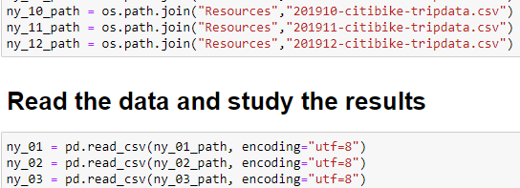
Figure 1: The image depicts the data extraction from a CSV file and read initiated in Jupyter notebook.

Data Modeling & Engineering:
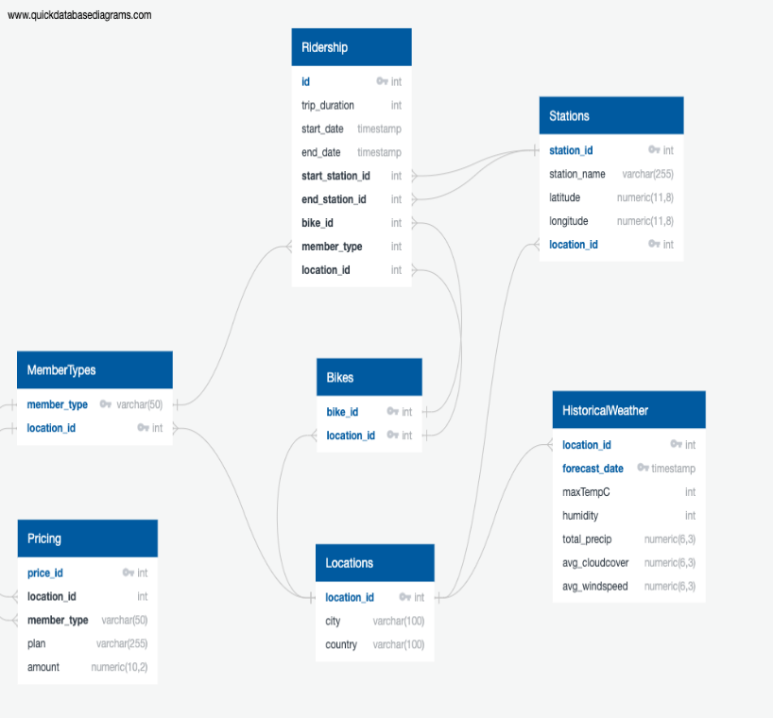
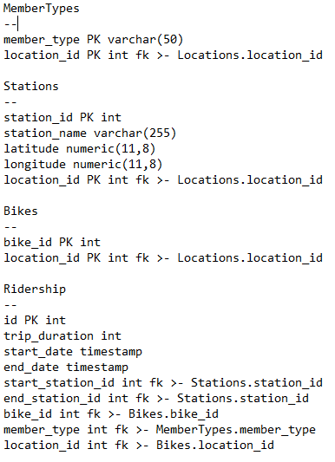
Due to various forms of a dataset, we created an Entity Relationship Diagram (ERD) to help sort our data and provide insight into merging our tables for our database. A database then created a based on the ERD aiming to look at seven main aspects regarding location, member type, pricing, station, bike, historical weather, and ridership information.
Figure 2: The left-hand side is a diagram that depicts the relationship between membership type, station, bike, ridership, historical weather, and price index information. On the right-hand side is a sample of the ERD script used to generate the diagram.

TRANSFORM
In the next stage we aimed to retrieve a clean dataset for each city. Since the data we are working with is an annual dataset we had to combine the monthly and quarterly files for each city to form a data set pertaining to bike share data in Toronto, Vancouver, Boston, and New York. Jupyter notebook was used to combine and clean the data.
Steps Taken:
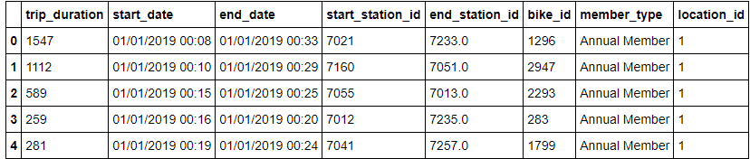
- Retrieved columns needed for analysis and dropped all extraneous columns
- Identified rows with incomplete information and dropped row with missing information
- Replaced the column names to be uniform across all four city datasets.
Figure 3: The image is a sample of a data frame that has been transformed to keep required information to analysis bike share data.

In a separate notebook we pulled the station & location information for each city. Jupyter notebook as used to retrieve the API data feeds and place the required data into a data frame.
Steps Taken:
- Created a get request to retrieve data on one city and then proceeded to print JSON for all launchpads
- A list was then created regarding the station and location data
- For loop was ingested to male request and parse the station’s URL and A data frame was then built from this pulled data
- A For Loop was then created to read scripts across all four city API data feeds.
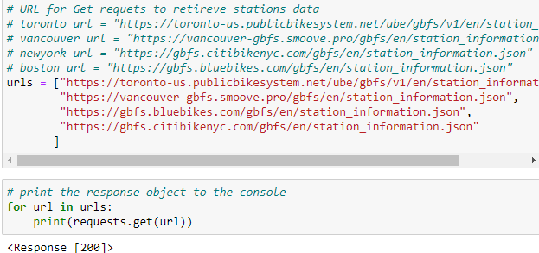

Figure 4: The image shows a station data being retrieved from a JSON and printing the response

The historical weather API data was combined and then cleaned to form a dataset pertaining to historical weather information that is likely to affect the ridership usage. Jupyter notebook was used to retrieve to combine and clean the data
Steps Taken:
- Retrieved columns needed for analysis and dropped all extraneous columns
- Identified rows with incomplete information and dropped row with missing information
- Replaced the column names to be uniform across all four city datasets.
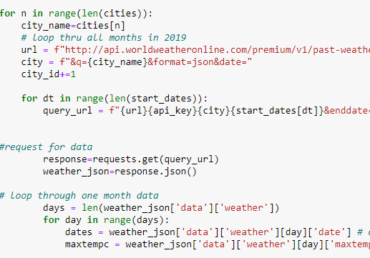
Figure 5: To the right we see a transformation script where a For Loop is used to pull historical API weather data for all four cities.
The pricing index was scraped from the bike share program websites to form a dataset. In the Jupyter notebook we set an executable path and retrieve the required data.
Steps Taken:
- Set Executable Path & Initialize Chrome Browser
- Visit the site and parse the HTML with BS (BeautifulSoup)
- Scraped the pricing index of transportation usage and time allocated fees.
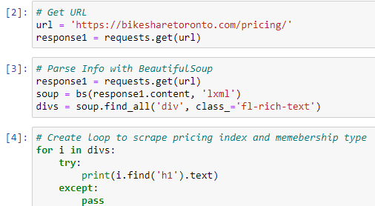

Figure 6: The image depicts a web scrape that was implemented. In this script sample we see the URL data retrieve, parsing of info and For Loop created to pull all price information

LOAD TO DATABASE
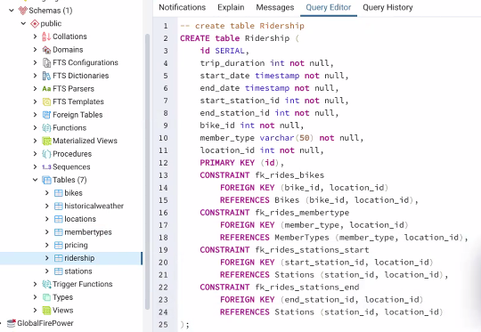
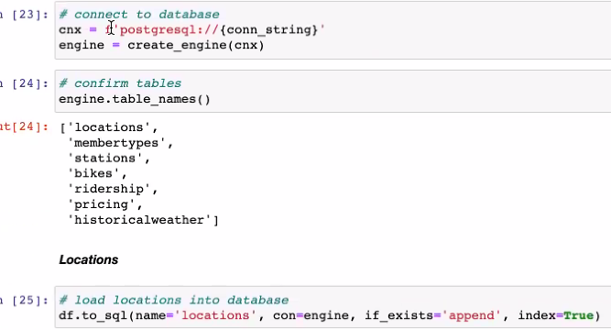
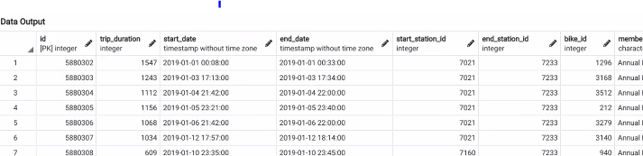
After the transformation, we proceeded to load the data frames into a Postgres cloud database through PG admin. With the schema file loaded into the Postgres database, we generated seven tables to display relevant information regarding location, member type, pricing, station, bike, historical weather, and ridership. Once we ran the queries with the relevant information, we reconnected to the database and generated additional tables for the data frames.
Figure 7: The left-hand image displays the connection to the database and the right-hand image displays the schema file in our data base. The bottom image reflects the output of the query in the database.

DISCUSSION
- We tried to find bike share data for other cities to complement the bike share data we used from project 1. However, most countries have greater privacy laws than Canada that limit information about members and their trip data. For this reason, we decided to go look for bike share programs in metropolitan areas in the USA where there is more likely to be established bike share programs with extensive data. We found that Boston and New York City used the same bike share data collection platform, so the information was easy enough to compare and parse.
- To complement our trip data, we found in additional information for the bike station information using a website called bikeshare-research.org that carried station information for all the cities we were looking at.
- We faced challenges finding accessible historical weather data because most weather sites only offer free current weather data. We found a site called worldweatheronline.com that offered a free trial for three months and allowed us to query monthly historical weather data. The json file structure was initially challenging to query and we developed layers of for loops to parse through the data.
- Web scraping was challenging since each site was different and had to be filtered differently. In some cases, we had to go into subdivisions and change classes to get the Member Type and price information.
- We used elephant SQL so that we could load tables and access them from different computers.

Limitations
- The station information is outdated, and we had to drop inconsistent records.
- No records on unique members for Vancouver, Boston, NYC
- The Database is only able to host up to 50MB of data. The data had to be limited to fulfill the availability of space on elephantSQL.
- Data collected may not be representative of each city demographic and may not be representative of other cities in Canada that want a bike share program

Next Steps
- Analyze our data to show:
  - Relationship between weather and ridership
  - Map station information to visually show station info
  - Popularity of different memberships based on price
- Display analysis on webpage in a visually appealing way

REFERENCES
Toronto
https://ckan0.cf.opendata.inter.prod-toronto.ca/download_resource/e69c5761-e0ed-4999-9426-8174f848b11a
https://toronto-us.publicbikesystem.net/ube/gbfs/v1/en/station_information
https://www.worldweatheronline.com/toronto-weather-history/ontario/ca.aspx
https://bikesharetoronto.com/pricing/
Vancouver
https://www.mobibikes.ca/en/system-data
https://vancouver-gbfs.smoove.pro/gbfs/en/station_information.json
https://www.worldweatheronline.com/vancouver-weather-history/british-columbia/ca.aspx
https://www.mobibikes.ca/en/offers-subscription
Boston
https://www.bluebikes.com/system-data
https://gbfs.bluebikes.com/gbfs/en/station_information.json
https://www.worldweatheronline.com/boston-weather/massachusetts/us.aspx
https://www.bluebikes.com/pricing
New York
https://www.citibikenyc.com/system-data
https://gbfs.citibikenyc.com/gbfs/en/station_information.json
https://www.worldweatheronline.com/new-york-weather/new-york/us.aspx
https://www.citibikenyc.com/pricing

